2.20: a) The bumper’s velocity and acceleration are given as functions of time by
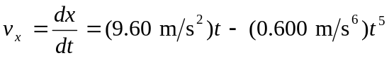
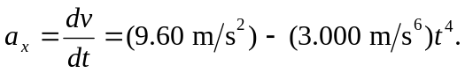

There are two times at which v = 0 (three if negative times are considered), given by t = 0 and t⁴ = 16 s⁴. At t = 0, x = 2.17 m and a_{x} = 9.60 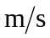 ². When t⁴ = 16 s⁴,
x = (2.17 m) + (4.80 ²) 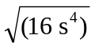– (0.100) 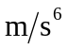)(16 s⁴)^{3/2} = 14.97 m,
a_{x} = (9.60 ²) – (3.000 )(16 s⁴) = –38.4 ².
b)
